For the Self-Healing project we will implement up to four channels capable of both reading in and playing back acoustic signals. The National Instruments 7853R FPGA DAQ card that we are currently using is capable of outputting a maximum power of 20V peak to peak. Although this is a sufficient voltage to drive the piezoelectric ceramic stacks, the current that it outputs is only 2.5mA. This low of a current was able to lightly excite the PZTs which produced a readable signal through a steel rod, but not at an amplitude that would be useful for our future testing. For these reasons, we made the decision to create a custom built, multi-channel, voltage/current amplifier.

For our amplifier circuits, we built four identical circuit boards using double sided copper PCB. The circuits were designed using Altium software. All of the components were soldered onto the milled boards and each amplifier circuit was tested to ensure it was within our specifications. One by one, the circuits were hooked up to a +-15V power supply. An analog sinusoidal signal from an AWG was fed into the board and the analog output signal from the board was fed to both a load (a PZT) and an oscilloscope. Each board proved to be capable of providing an amplification of ~30V peak to peak and a current of up to ~2.0A. The boards were all able to process a sinusoidal signal that was greater than 100Khz in frequency. This is a more than sufficient range for what we need right now. So these amplifier boards are what we will use for the testing.

For the case of our amplifier, we used a shell from a non-working computer power supply. We cleaned out all of the internals of the power supply except for the 12V DC cooling fan. The case was painted a different color from its original machine gray in order to give a more professional appearance and offer aesthetic appeal. After painting the case, a 120V AC to 12V DC power converter was mounted inside and wired to the 12V DC cooling fan. The plug input for the power converter uses the same hole that was used for the stock power supply. Mounts for the amplifier boards were created from 1/2" PVC piping and were glued to the bottom of the case. The boards were fitted into these mounts, and holes were machined into the top of the case lid to allow for the protrusion of the BNC inputs and outputs from the circuit boards. Two 15V power supplies were used to power the four amplifiers. One power supply acts as the +15V source and the other acts as the -15V source. The cords of the power supplies had to be modified in order to allow for them to be used in this manner. The supplies were mounted to the sides of the case using Velcro material which allows for easy swapping of components. The three power cords were tied together into a single, thicker AC power cord so that only one outlet is required to power the amplifier unit instead of three. Below are pictures of the completed and assembled custom four channel amplifier.

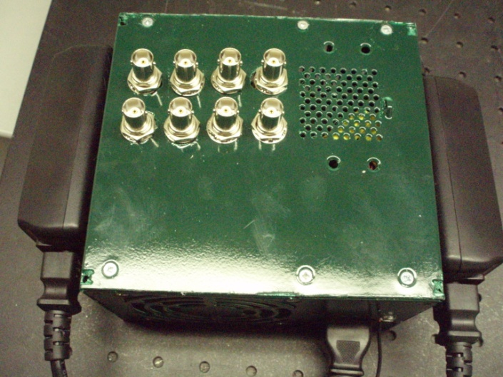

Figure Top View of Amplifier

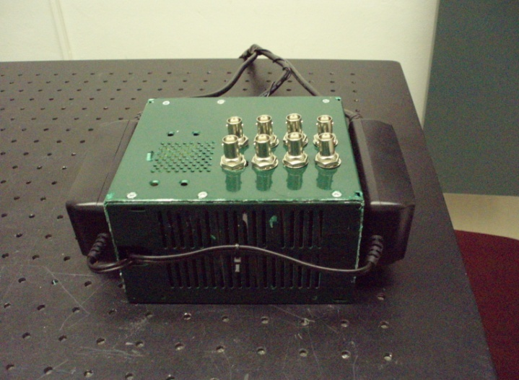

Figure Front View of Amplifier

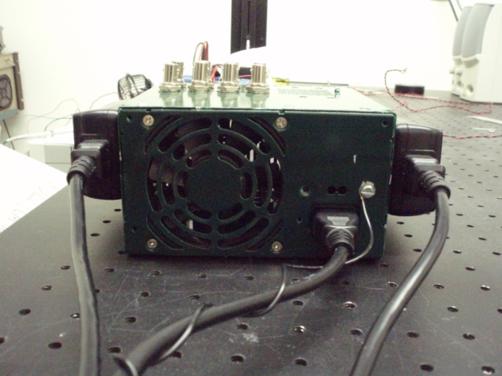

Figure Back View of Amplifier

Many tests have been performed with the Time-Reversal portion of the Self-Healing project. The testing has been done using two primary setups. One of the setups is detailed in the 2010 AIAA extended abstract for the Self-Healing. Essentially, it is using the 1 foot steel rod and piezoelectric ceramic stacks that are tensioned with heavy duty switchable magnetic bases. Three PZTs are used. Two PZTs act as transducers (send/receive), while the third only reads from the point in which we wish to focus. The other setup used is similar, except it uses a custom tensioning mechanism. This setup was detailed in the last quarterly report.

The first priority was to reproduce the same results that were described in both the 2010 AIAA and 2010 SPIE extended abstracts. We first used the setup with the switchable magnetic bases that were used for the written results. We then inducted our amplifier into this system and were able to obtain the same results as what we had before. The same testing was performed using the second setup with the custom tensioner. Again, we were able to produce the same results.

It has been found that tension affects the amplitude that is achieved in the system. Thus, reliable and consistent tension will have to be a concern for the future. Both setups will hold their tension once clamped down, but it is not yet reliable that the same tension is achieved when either system is un-clamped and then re-clamped. This will be an issue that will need to be sorted out at some point, but it not a major problem for now. At this time, we will just be using the custom tensioner system and will only compare results that are produced from tests performed on a system that has remained clamped (i.e., we will not run tests, un-clamp and re-clamp the system, then perform tests and try to compare those results directly to tests from before we re-clamped the system).

The testing performed was setup so that the PZT that sends the initial signal is on the opposite side of the steel rod from the "defect" PZT. This "defect" PZT was placed behind the transducer PZT on that side (see below). In order to further validate the time-reversal, we decided to perform testing with the "defect" PZT placed behind the PZT that sends the initial signal (see below). All of the current testing is being done on this setup.

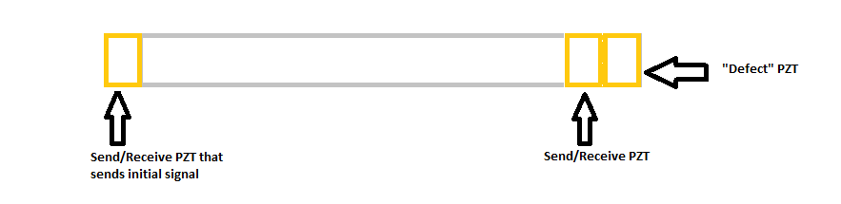

Figure Rod Setup with "Defect" PZT on Receiving Side

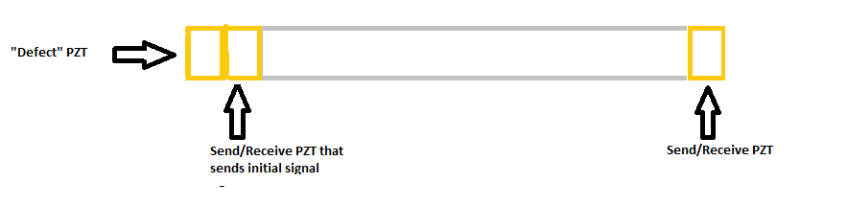

Figure Rod Setup with "Defect" PZT on Sending Side

One task that has been performed is to determine the optimal frequency of the initial pulse. We have been using a 100 KHz sinusoidal pulse and discovered this was not necessarily the best frequency to use. Through testing, we found that a wave of roughly ~145KHz produces the highest response from the PZTs. It was also found that care must be taken when setting this up in LabVIEW and that one must pay attention to the output sampling frequency that is specified for the DAQ card as this greatly affects the results.

Filtering is another issue that has been dealt with. During testing it was found that a large spike was being read in at both transducer PZTs at the exact same moment. This spike was at the very beginning of the data read in. Due to the speed of sound through a steel rod, it was physically impossible for both transducer PZTs to be reading the same wave at the same time. It was first hypothesized that the rod was being physically pushed. A force transducer was put into the system in place of the "defect" PZT to test this theory. The force transducer did also read in the same spike. Further testing, however, uncovered that this spike is actually an artifact of the filter that is used and is independent of the data that is passed to it (i.e., the same spike is seen regardless of the data passed in). To overcome this, we found that we can append the data array to its self, filter the newly created array, and then throw away the first half of the array to obtain a filtered data set that did not have an artificial spike in the beginning of the set.

Most recent testing has involved looking at the amplitude achieved at the "defect" PZT using non-algorithmic signal play versus algorithmic playback. This testing is of great importance because for the Time-Reversal to be useful it must be able to produce higher amplitudes at the "defect" than what is obtained by just playing large amplitude signals without regard to the Time-Reversal algorithm. The main test has been to send signals from the sending side PZT while recording at the "defect" PZT that is placed behind it. It has been found that very large amplitudes (almost the max voltage that the card can read in) are achieved by playing a long sinusoidal pulse from the sending side PZT. The length of the pulse (number of data points used) affects the amplitude that is reached at the "defect" PZT. The max amplitude obtained steadily increases as the length of the pulse is increased to a certain point and then it somewhat levels off. It appears that the point at which it starts to level off is when the pulse is at a length such that the reflections of it from the opposite side of the sending PZT would be reaching the sending side PZT. This will be investigated further. The amplitudes that are seen from the non-algorithmic playback are actually higher than what we get with the Time-Reversal algorithm playback. The algorithm that is used as of now is currently being revised. We will also revisit the setup with the "defect" PZT on the receiving side as new discoveries have been made since that testing was performed.